**#WHAT IS STATISTIC**

-Measure of Center : to see the best option between mean and median, look at the skew of the graph. If left or right skew then choose median. If normal distribution used mean.

-Mean and Median :

# Filter for Belgium

belgium_consumption <- food_consumption %>%

  filter(country == "Belgium")

# Filter for USA

usa_consumption <- food_consumption %>%

  filter(country == "USA")

# Calculate mean and median consumption in Belgium

mean(belgium_consumption$consumption)

median(belgium_consumption$consumption)

# Calculate mean and median consumption in USA

mean(usa_consumption$consumption)

median(usa_consumption$consumption)

food_consumption %>%

  # Filter for Belgium and USA

  filter(country %in% c("Belgium", "USA")) %>%

  # Group by country

  group_by(country) %>%

  # Get mean_consumption and median_consumption

  summarise(mean_consumption = mean(consumption),

      median_consumption = median(consumption))

-mean vs median

food_consumption %>%

  # Filter for rice food category

  filter(food_category == "rice") %>%

  # Create histogram of co2_emission

  ggplot(aes(co2_emission)) +geom_histogram()

food_consumption %>%

  # Filter for rice food category

  filter(food_category == "rice") %>%

  # Create histogram of co2_emission

  ggplot(aes(co2_emission)) +

    geom_histogram()

food_consumption %>%

  # Filter for rice food category

  filter(food_category == "rice") %>%

  # Get mean_co2 and median_co2

  summarize(mean_co2 = mean(co2_emission),

            median_co2 = median(co2_emission))

-Measure of Spread

-Variances : Average distance from each data point to the data’s mean

**-how to calculate variance :**

**\*dists <- msleep$sleep_total – mean(msleep$sleep_total) [deviate each data point with mean of total]**

**\*square_dists <- (dists)^2**

**\*sum_sq_dists <- sum(square_dists)**

**\*variance = sum_sq_dists/(number of sample-1)**

-The higher variance, the more spread out the data

-Calculate variance using one step :

**\*var(msleep$sleep_total)**

-Standard Deviation

**\*sqrt(var(msleep$sleep_total)**

**\*sd(msleep$sleep_total)**

-Mean Absolute Deviation

**\*dists <- msleep$sleep_total – mean(msleep$sleep_total)**

**\*mean(abs(dists))**

-Quartiles :

**\*quantile(msleep$sleep_total)** -> showing quartile of each data

**\*quantile(msleep$sleep_total, probs = seq(0,1,0.2))** ->showing quartile form 0%-100% with jump every 20%

-IQR (Interquartile range) : Height of the box in boxplot

**\*quantile(msleep$sleep_total, 0.75) –quantile(msleep$sleep_total, 0.25)**

-Outliers : data point that is substantially different from the others

**If data <Q1-1.5 x IQR or if data > Q3 + 1.5 x IQR**

-Finding Outlier :

**\*iqr <- quantile(msleep$bodywt, 0.75) – quantile(msleep$bodywt, 0.25)**

**\*lower_threshold <- quantile(msleep$bodywt, 0.25) – 1.5*iqr**

**\*upper_threshold <- quantile(msleep$bodywt, 0.75) + 1.5*iqr**

**\*msleep %>% filter(bodywt < lower_threshold | bodywt > upper_threshold) %>%**

**select(name, vore, sleep_total, bodywt)**

-Quartiles, Quantile, Quintiles :

# Calculate the quartiles of co2_emission

quantile(food_consumption$co2_emission)

# Calculate the quintiles of co2_emission

quantile(food_consumption$co2_emission, probs = seq(0,1,0.2))

# Calculate the deciles of co2_emission

quantile(food_consumption$co2_emission, probs = seq(0,1,0.1))

-Varaince and Standard Deviation :

# Calculate variance and sd of co2_emission for each food_category

food_consumption %>%

  group_by(food_category) %>%

  summarize(var_co2 = var(co2_emission),

     sd_co2 = sd(co2_emission))

# Plot food_consumption with co2_emission on x-axis

ggplot(food_consumption, aes(co2_emission)) +

  # Create a histogram

  geom_histogram() +

  # Create a separate sub-graph for each food_category

  facet_wrap(~ food_category)

-Finding Outlier using IQR :

# Calculate total co2_emission per country: emissions_by_country

emissions_by_country <- food_consumption %>%

  group_by(country) %>%

  summarize(total_emission = sum(co2_emission))

# Compute the first and third quantiles and IQR of total_emission

q1 <- quantile(emissions_by_country$total_emission, 0.25)

q3 <- quantile(emissions_by_country$total_emission, 0.75)

iqr <- q3 - q1

# Calculate the lower and upper cutoffs for outliers

lower <- q1 - 1.5 * iqr

upper <- q3 + 1.5 * iqr

# Filter emissions_by_country to find outliers

emissions_by_country %>%

  filter(total_emission<lower | total_emission>upper)

**#RANDOM NUMBERS AND PROBABILITY**

-What are the chances

-Sampling from a data frame

**\*sales_count %>%  
*sample_n (1) -> Get the random result**

-Setting the random seed : to get the same result when we take the sample

**\*set.seed(100) -> random urutan ke 100**

**\*sales_count %>%**

**\*sample_n(1)** -> the result will always be same due to of set.seed

-Sampling with replacement : Sample will be back to drawing after the sample choose

**\*sales_count %>%**

**\*sample_n(2, replace = TRUE)** - > If there are 2 lottery

If there are 5 lottery

**\*sample(sales_team, 5, replace = TRUE)**

-Sampling without replacement : Sample won’t be back to drawing after the sample choose

-Independent Events : two events are independent if the probability of the second event isn’t affected by the outcome of the first event.

-Dependent Events : two events are dependent if the probability of the second event is affected by the outcome of the first event

-sampling without replacement = each pick is dependent

-sampling with replacement = each pick is independent

-Calculating Probabilities

# Calculate probability of picking a deal with each product

amir_deals %>%

  count(product) %>%

  mutate(prob = n/sum(n))

-Discrete Distribution : Uniform discrete distribution

-Visualizing the sample of dice

**\*ggplot(rolls_10, aes(n)) + geom_histogram(bins = 6)**

-Law of large number : as the size of your sample increases, the sample mean will approach the expected value.

-Creating Probability distribution :

# Create a histogram of group_size

ggplot(restaurant_groups, aes(group_size)) +

  geom_histogram(bins = 5)

# Create probability distribution

size_distribution <- restaurant_groups %>%

  count(group_size) %>%

  mutate(probability = n / sum(n))

# Calculate expected group size

expected_val <- sum(size_distribution$group_size*          size_distribution$probability)

expected_val

# Create probability distribution

size_distribution <- restaurant_groups %>%

  count(group_size) %>%

  mutate(probability = n / sum(n))

# Calculate probability of picking group of 4 or more

size_distribution %>%

  # Filter for groups of 4 or larger

  filter(group_size>=4) %>%

  # Calculate prob_4_or_more by taking sum of probabilities

  summarise(prob_4_or_more = sum(probability))

-Continous distribution

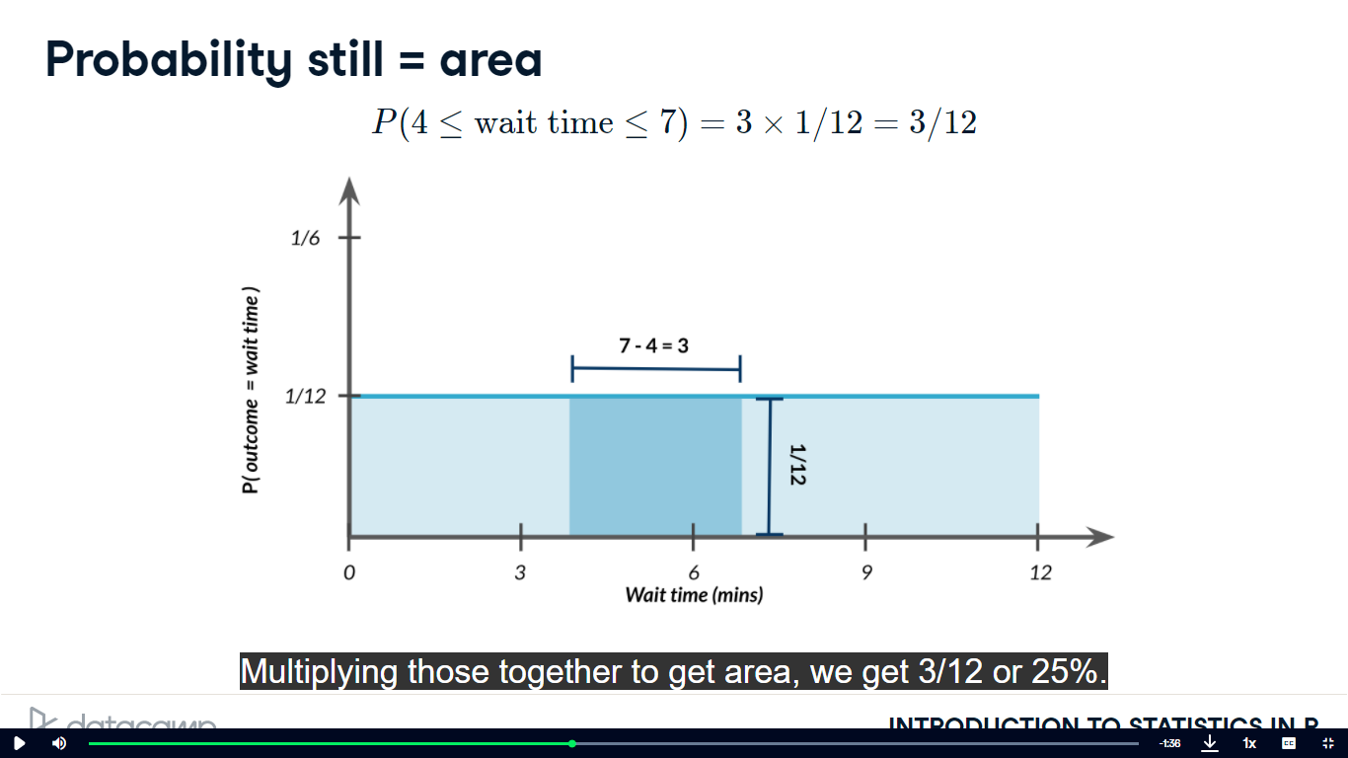

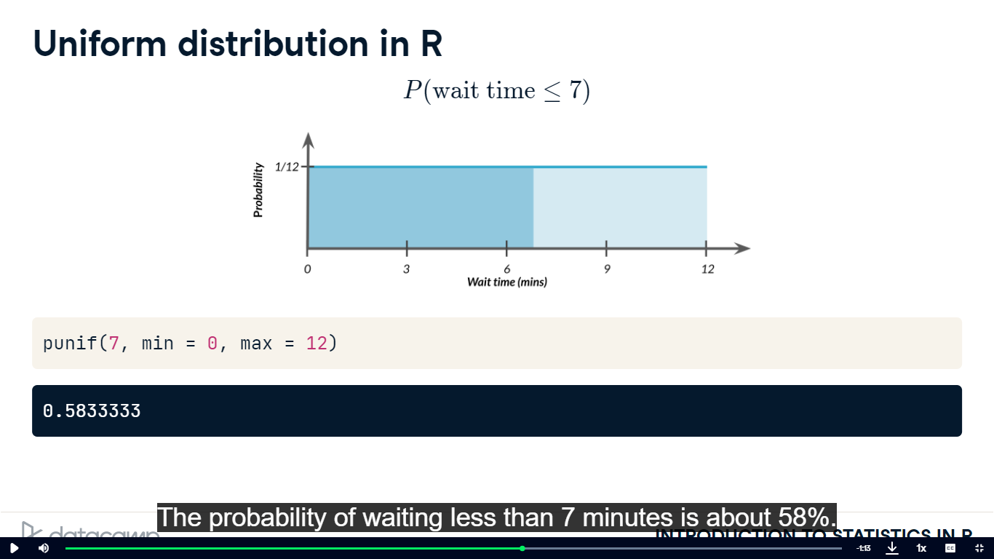

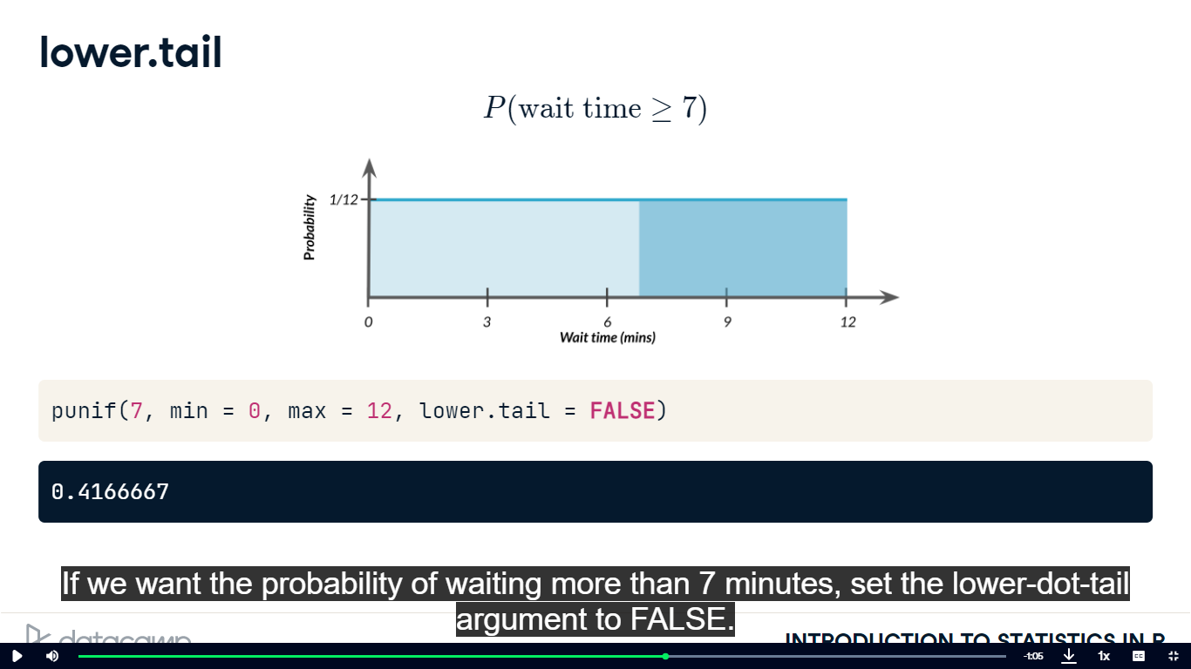

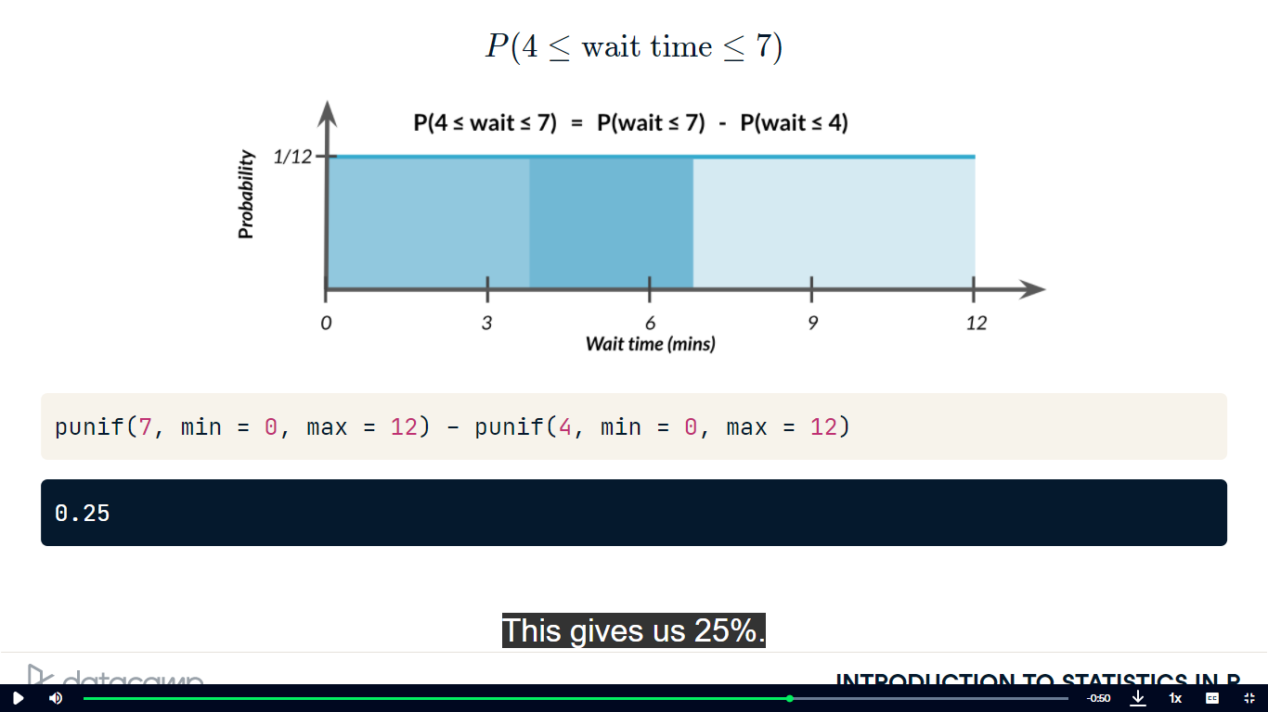

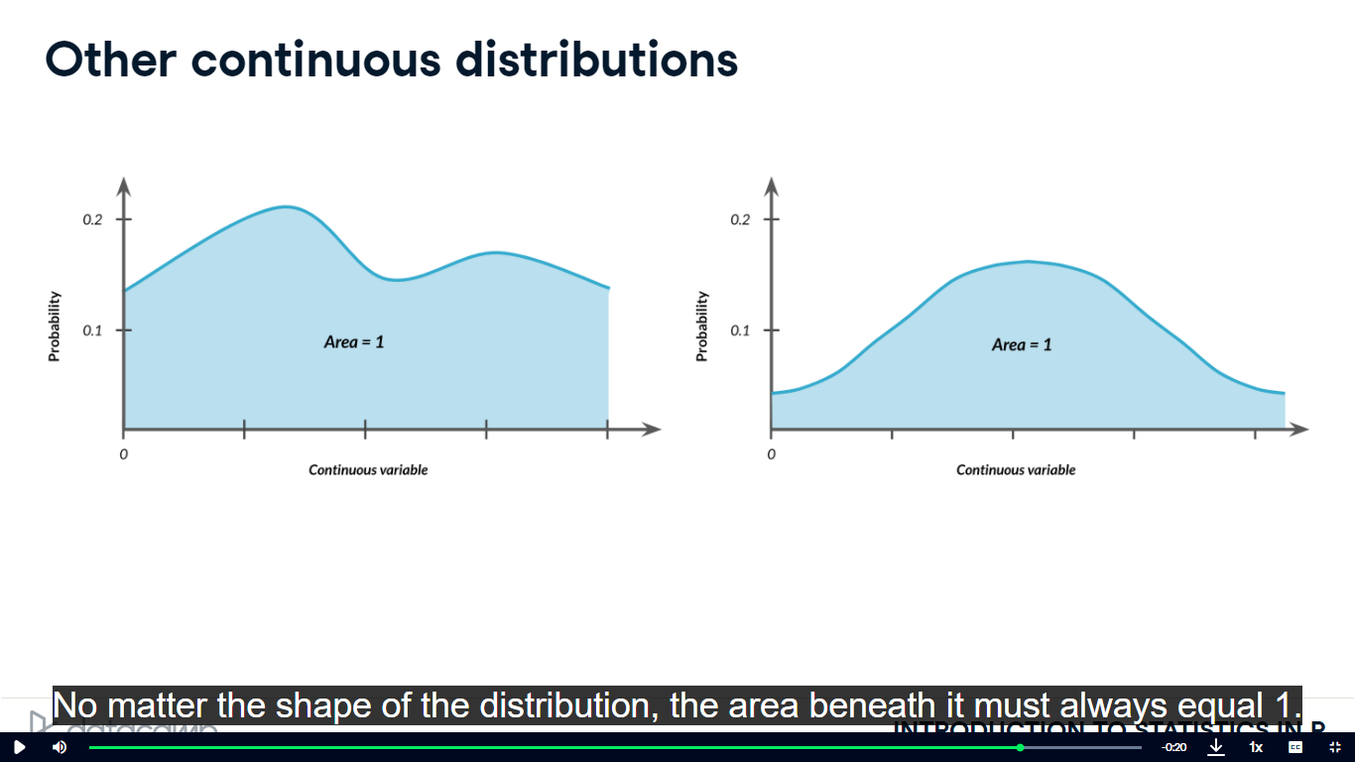

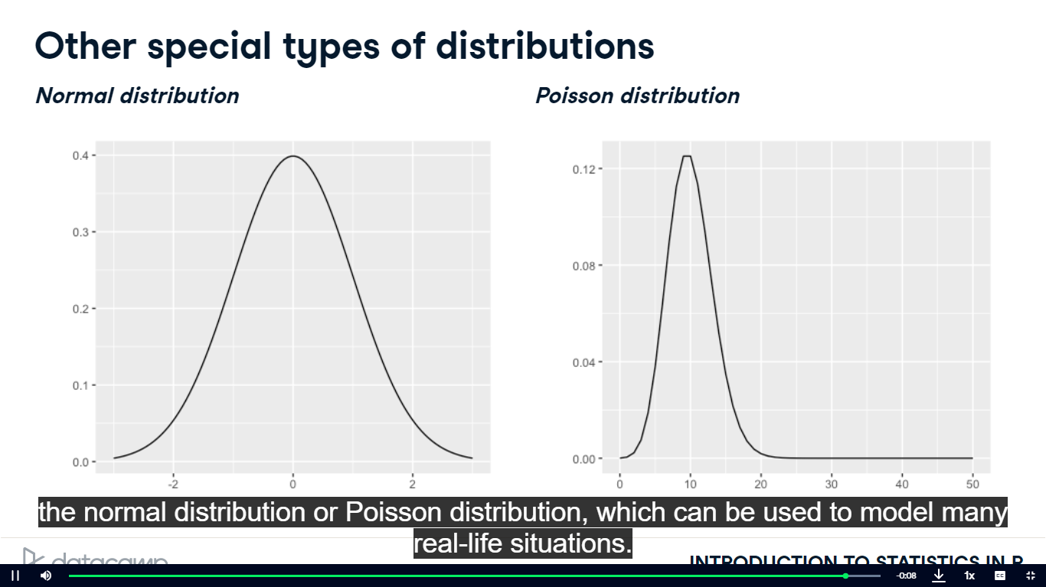

-Data Backups

# Min and max wait times for back-up that happens every 30 min

min <- 0

max <- 30

# Calculate probability of waiting less than 5 mins

prob_less_than_5 <- punif(5, min = 0, max = 30)

prob_less_than_5

# Min and max wait times for back-up that happens every 30 min

min <- 0

max <- 30

# Calculate probability of waiting more than 5 mins

prob_greater_than_5 <- punif(5, min = 0, max = 30, lower.tail = FALSE)

prob_greater_than_5

# Min and max wait times for back-up that happens every 30 min

min <- 0

max <- 30

# Calculate probability of waiting 10-20 mins

prob_between_10_and_20 <- punif(20, min = 0, max = 30) - punif(10, min = 0, max = 30)

prob_between_10_and_20

-Simulating wait times

# Set random seed to 334

set.seed(334)

# Generate 1000 wait times between 0 and 30 mins, save in time column

wait_times %>%

  mutate(time = runif(1000, min = 0, max = 30)) %>%

  # Create a histogram of simulated times

  ggplot(aes(time)) +

  geom_histogram(bins=30)

-The Binomial Distribution

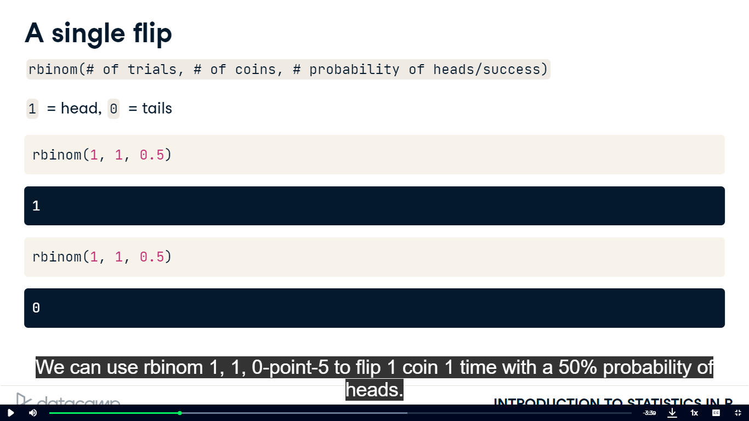

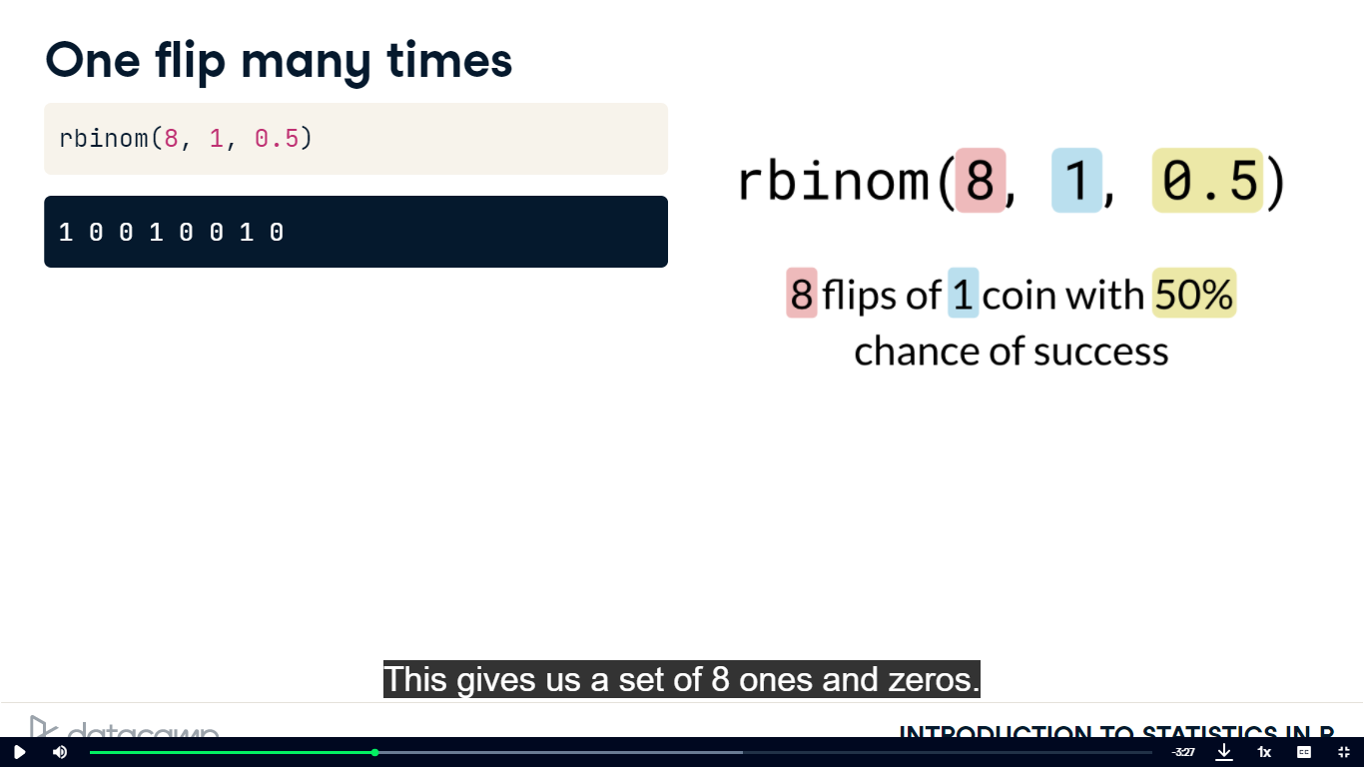

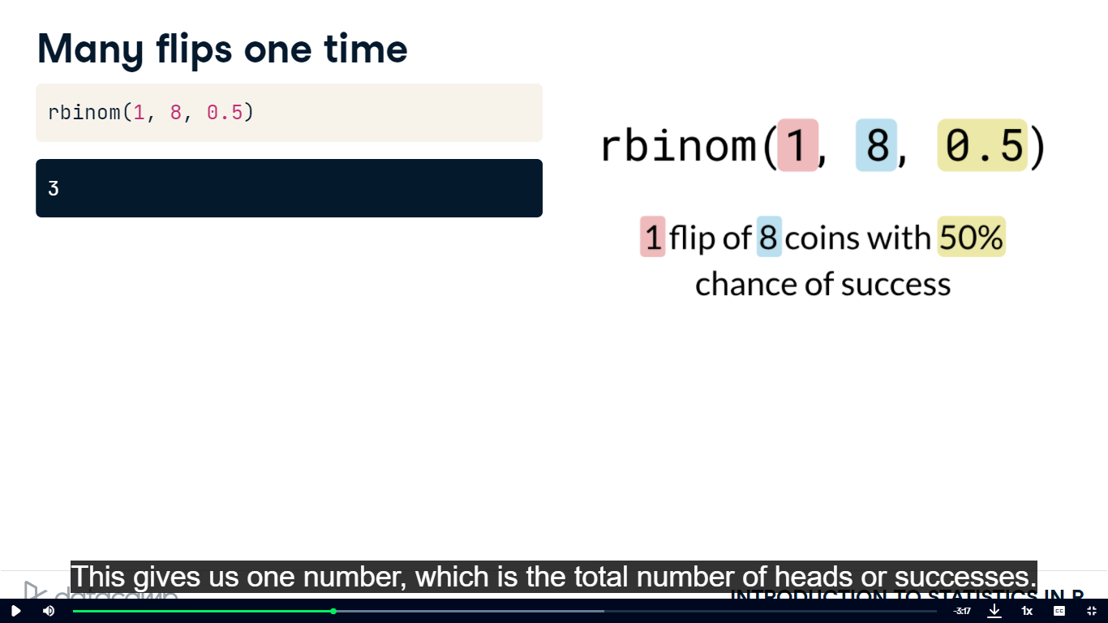

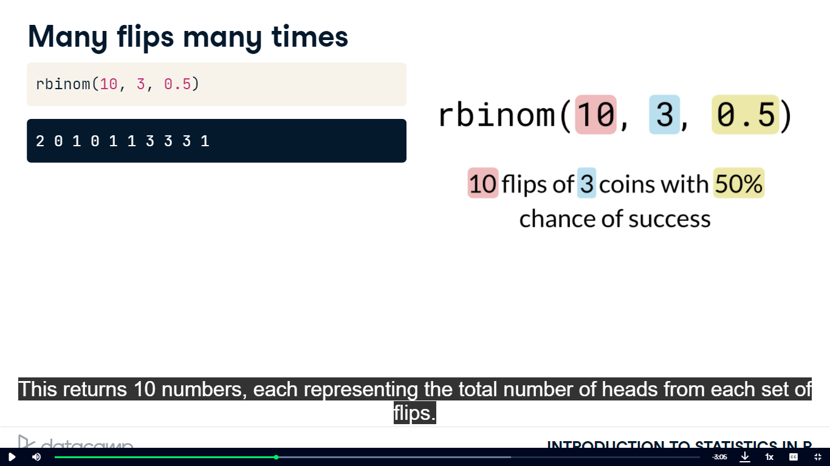

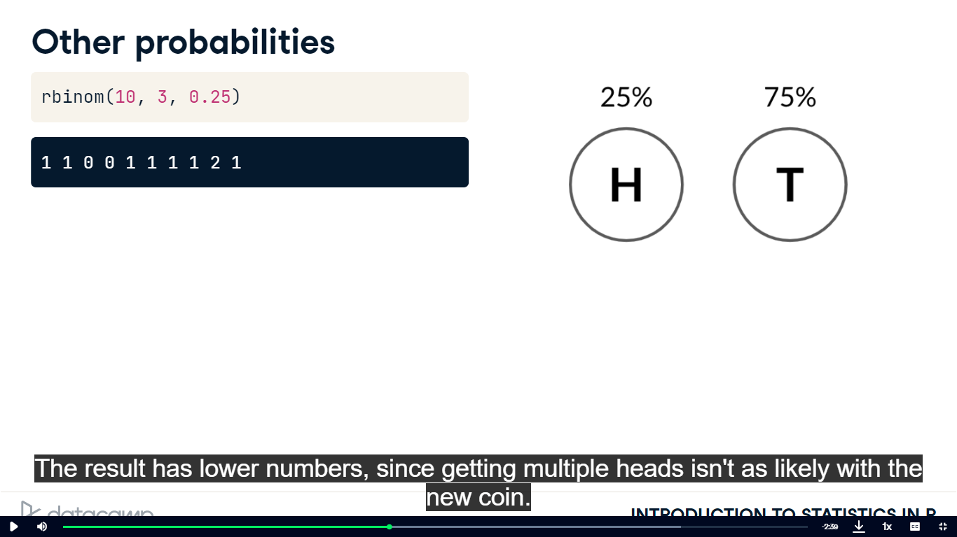

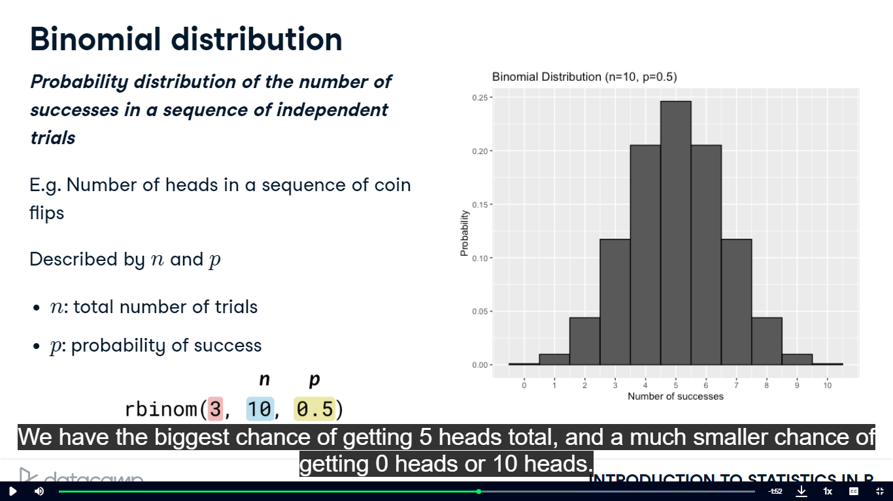

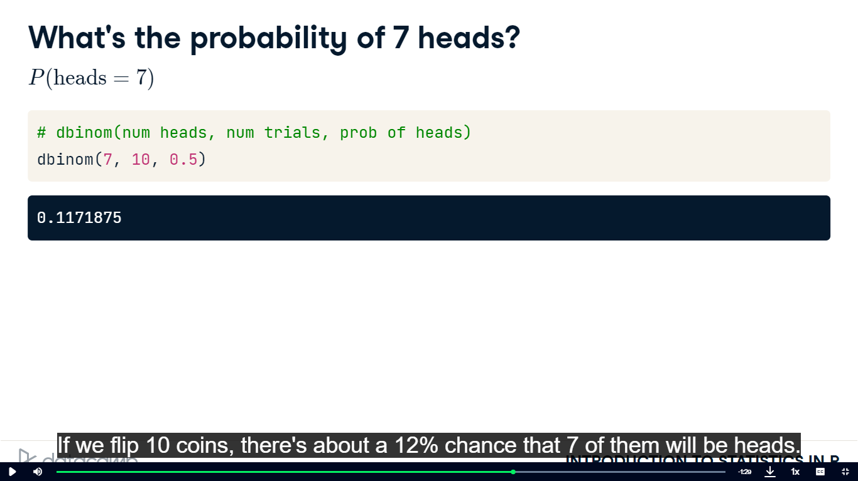

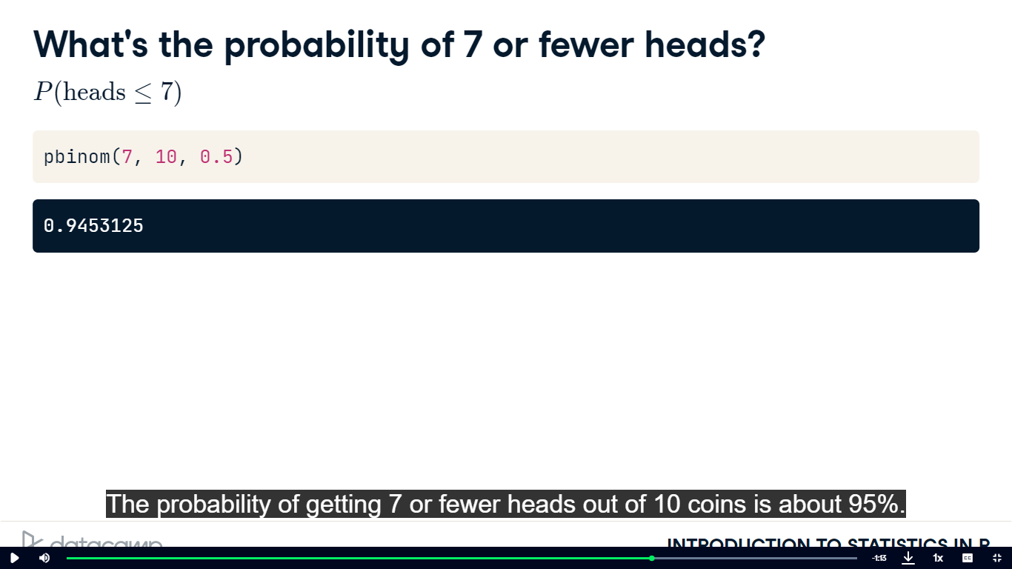

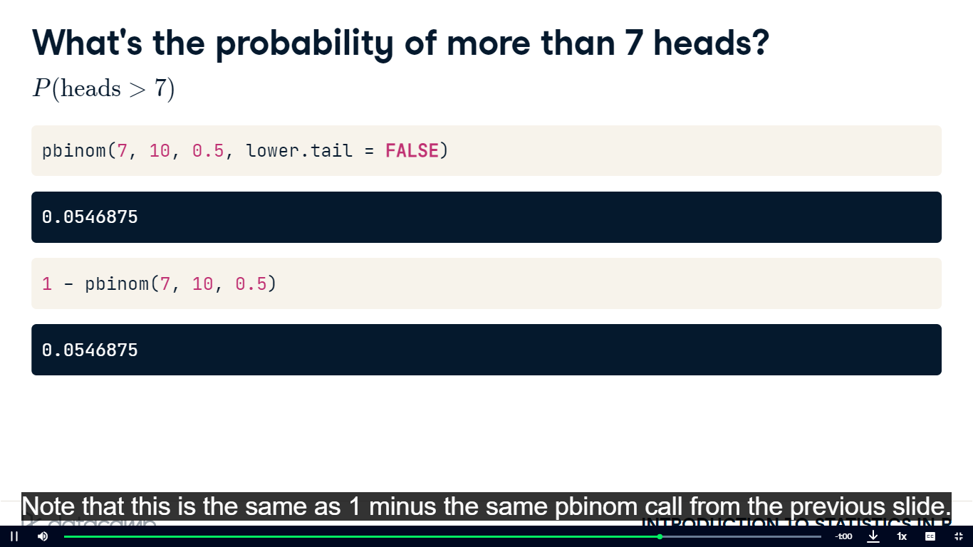

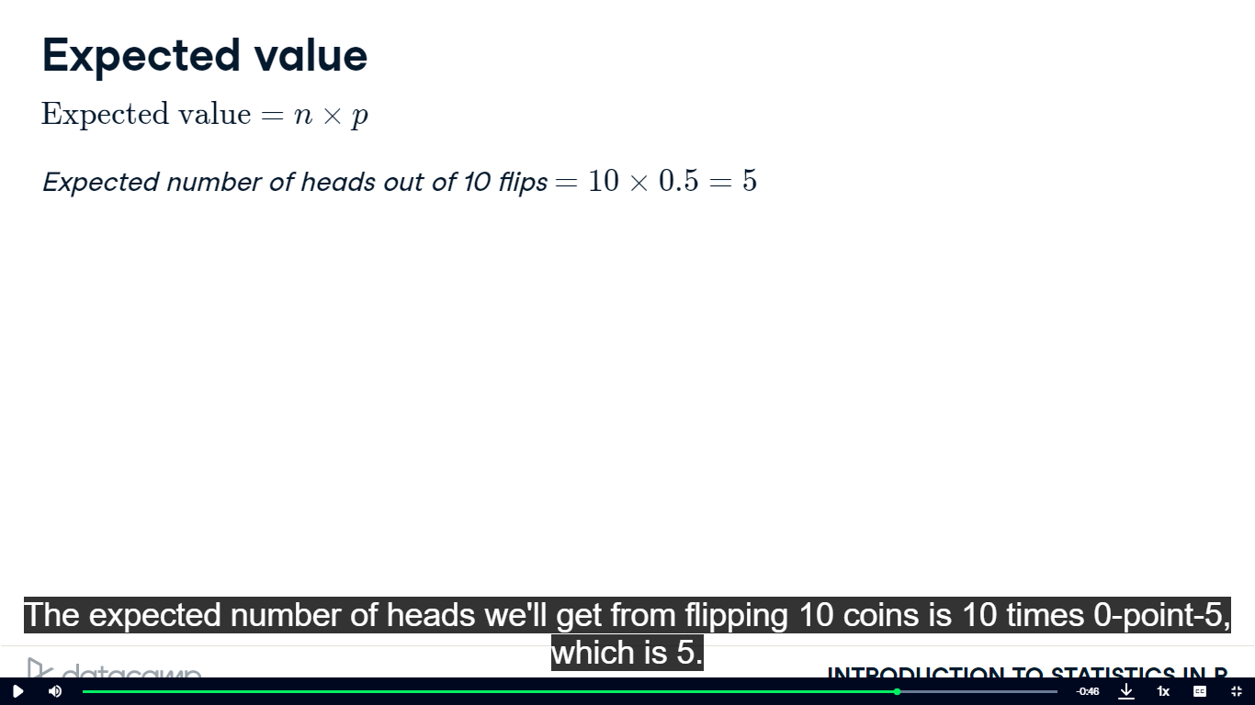

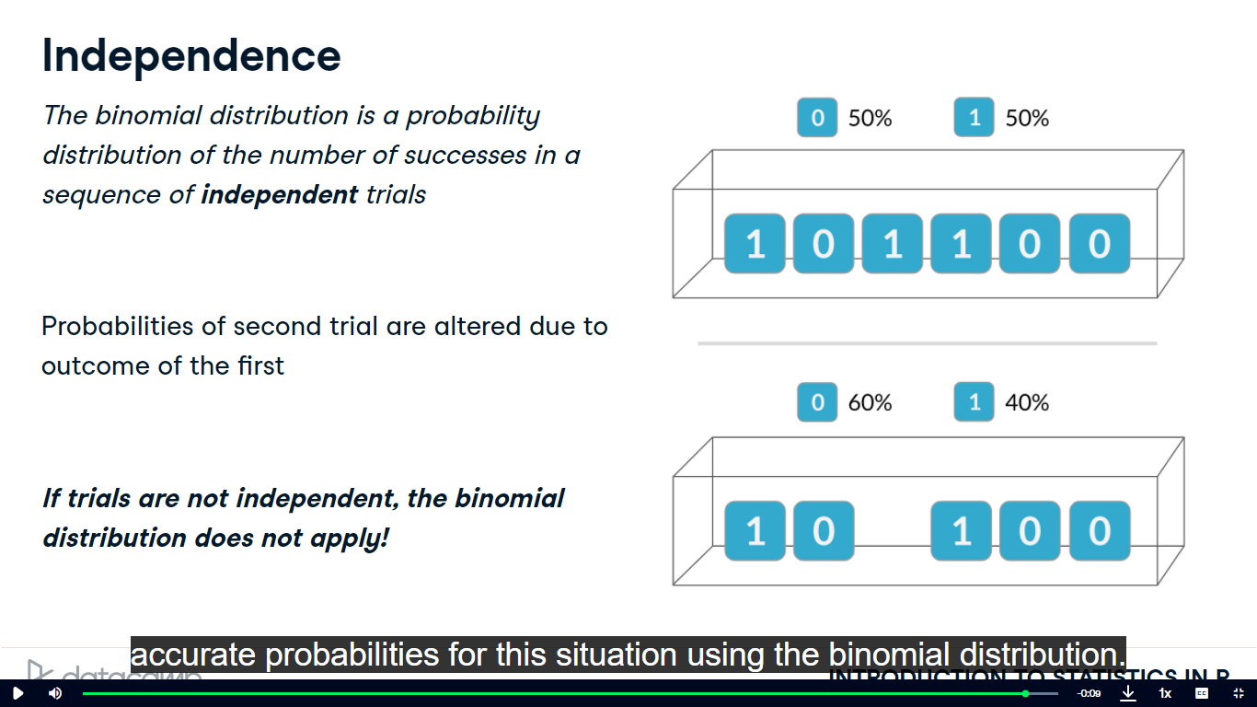

-Simulating Sales Deal

# Set random seed to 10

set.seed(10)

# Simulate a single deal

rbinom(1,1,0.3)

# Set random seed to 10

set.seed(10)

# Simulate 1 week of 3 deals

rbinom(1,3,0.3)

# Set random seed to 10

set.seed(10)

# Simulate 52 weeks of 3 deals

deals <- rbinom(52,3,0.3)

# Calculate mean deals won per week

mean(deals)

-Calculating Binomial Probabilities

# Probability of closing 3 out of 3 deals

dbinom(3,3,0.3)

# Probability of closing <= 1 deal out of 3 deals

pbinom(1,3,0.3)

# Probability of closing > 1 deal out of 3 deals

pbinom(1,3,0.3, lower.tail=FALSE)

-How many sales will be won

# Expected number won with 30% win rate

won_30pct <- 3 * 0.3

won_30pct

# Expected number won with 25% win rate

won_25pct <- 3*0.25

won_25pct

# Expected number won with 35% win rate

won_35pct <- 3*0.35

won_35pct